**Accessing the Gizmo:**

1. Go to: [www.explorelearning.com](http://www.explorelearning.com)
2. Click on the “Enroll in a Class” button in the upper right hand corner of the web page.

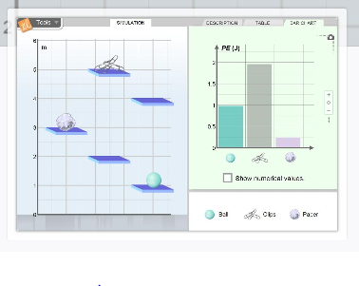

1. Type in your teacher’s class code: NGYZVRAFGF
2. Click “Continue” and follow the directions on the   
   site to complete your enrollment.
3. Open the gizmo titled “Potential Energy on Shelves”.

**Exploration Questions:**

1. What is the relation between an object’s position and its gravitational potential energy? (Show your measurements and analysis.)
2. Is this relation the same for all objects? (Show your measurements and analysis.)
3. Which of the three objects in the simulation is the lightest? (Justify your answer)
4. Why does changing an object’s horizontal position have no effect on its gravitational potential energy?
5. How do you think that mass and gravity are related to an object’s potential energy?
6. Why would an object’s gravitational potential energy be higher if it was 100 m above the surface of Jupiter instead of 100 m above Earth?
7. Why does increasing an object’s height and/or mass increase its gravitational potential energy?
8. What would result in the bigger change in potential energy: moving the ball from the 1m shelf to the 3m shelf or moving the ball from the 3m shelf to the 5m shelf? (Explain your answer.)
9. If the simulation started at a height of 10m instead of a height 0m, how would this change things?